**Cloud Console Connection:**

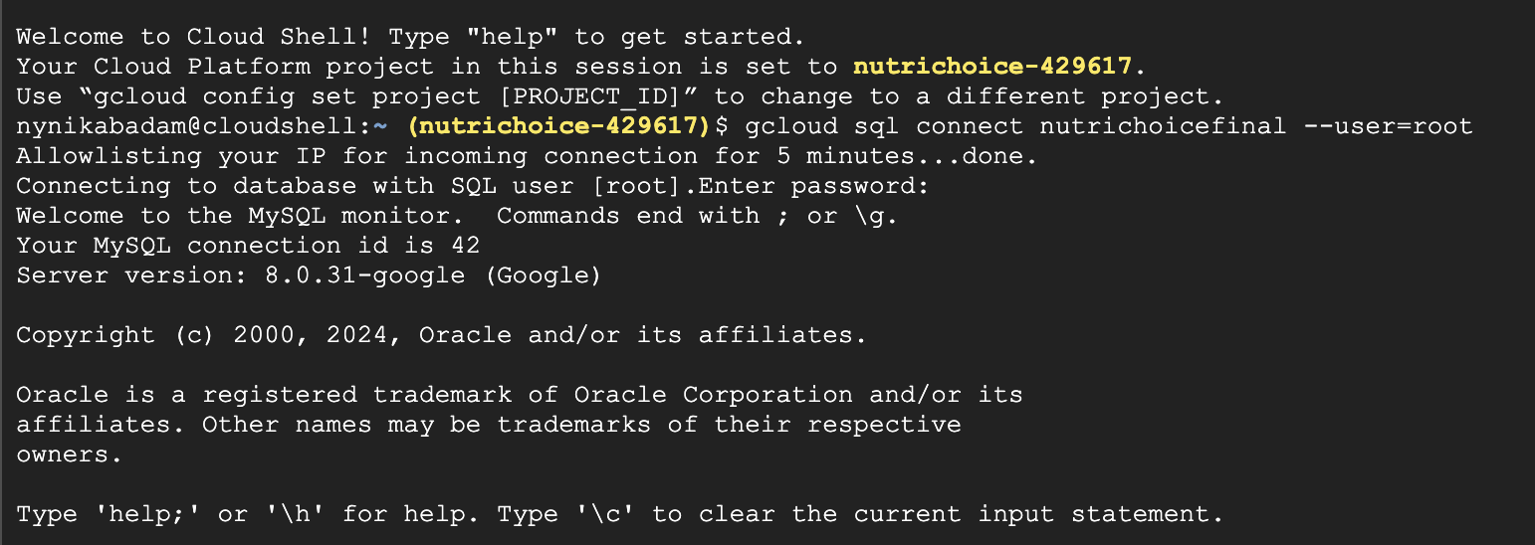

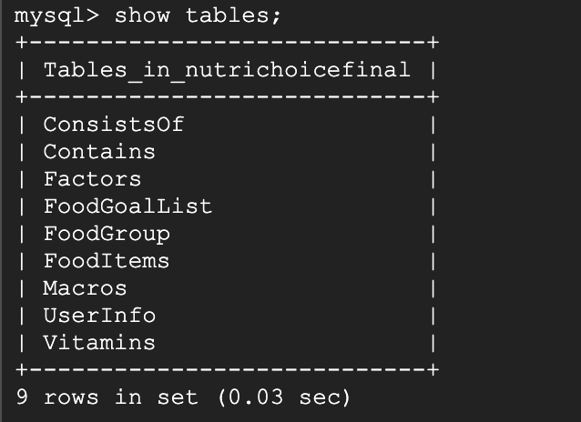

**DDL Commands::**

CREATE TABLE UserInfo (

UserId INT PRIMARY KEY,

Password VARCHAR(100),

Customer_Name VARCHAR(100),

Height DECIMAL,

Weight DECIMAL,

Age INT

);

**starts empty

CREATE TABLE Factors (

ProgressID INT PRIMARY KEY,

Goal_Intake DECIMAL,

Current_Intake DECIMAL,

UserID INT,

FOREIGN KEY (UserId) REFERENCES UserInfo(UserId)

);

**starts empty

CREATE TABLE FoodItems (

FoodId INT PRIMARY KEY,

ServingSize INT,

FoodName VARCHAR (100)

);

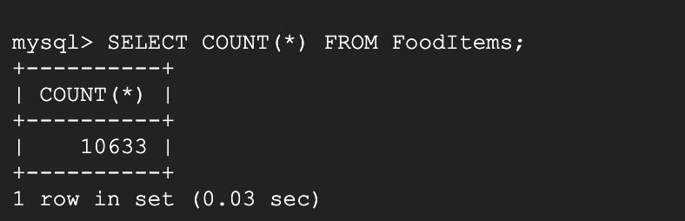

CREATE TABLE Vitamins (

VitaminID INT PRIMARY KEY,

VitaminName VARCHAR(100),

VitAmount DECIMAL

);

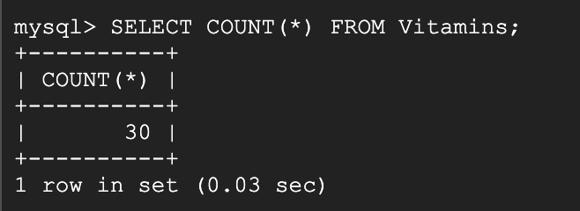

CREATE TABLE Macros(

MacroID INT PRIMARY KEY,

MacroName VARCHAR(100),

MacAmount DECIMAL

);

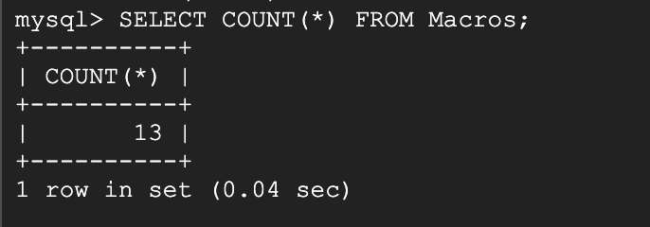

CREATE TABLE FoodGroup(

GroupID INT PRIMARY KEY,

GroupName VARCHAR(100)

);

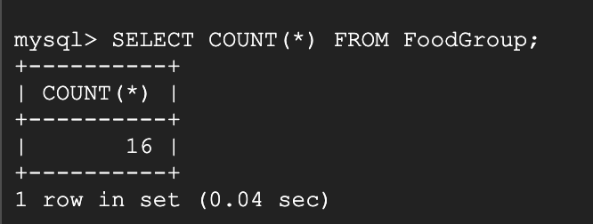

CREATE TABLE FoodGoalList (

ServingSize INT,

FoodName VARCHAR (100),

UserID INT,

ProgressID INT,

PRIMARY KEY(UserID, ProgressID),

FOREIGN KEY (ProgressID) REFERENCES Factors(ProgressID),

FOREIGN KEY (UserID) REFERENCES UserInfo(UserID)

);

**starts empty

CREATE TABLE Contains(

FoodID INT,

VitaminID INT,

PRIMARY KEY(FoodID, VitaminID),

VitAmount DECIMAL,

FOREIGN KEY (FoodID) REFERENCES FoodItems(FoodID),

FOREIGN KEY (VitaminID) REFERENCES Vitamins(VitaminID),

);

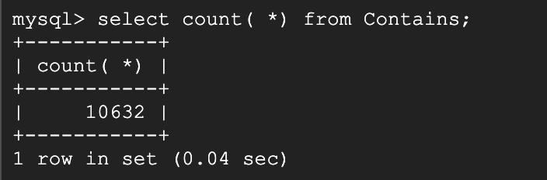

CREATE TABLE ConsistsOf(

FoodID INT,

MacroID INT,

PRIMARY KEY(FoodID, MacroID),

MacAmount DECIMAL,

FOREIGN KEY (FoodID) REFERENCES FoodItems(FoodID),

FOREIGN KEY (MacroID) REFERENCES Macros(MacroID)

);

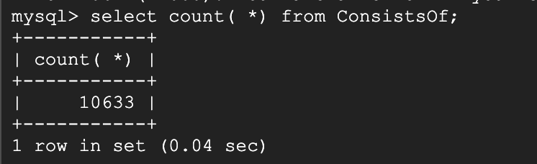

**Advanced SQL Queries**

1. Generate table of all food items corresponding to user indicated vitamin - join and groupby

SELECT f.FoodName, v.VitaminName

FROM Contains c

JOIN Vitamins v ON c.VitaminID = v.VitaminID

JOIN FoodItems f on c.FoodID = f.FoodID

JOIN Ate a ON f.FoodID = a.FoodID

JOIN Factors fac ON fac.UserID = a.UserID

WHERE fac.UserID = ‘[user_id]’ AND v.VitaminName = ‘[vitamin_name]’

GROUP BY fac.UserID, v.VitaminName

1. Setting current intake for vitamin - set and join

UPDATE Factors

SET GoalIntake = 20

WHERE UserID = 1

AND EXISTS (

SELECT 1

FROM Contains c

JOIN Vitamins v ON c.VitaminID = v.VitamindID

JOIN FoodItems f on c.FoodID = f.FoodID

WHERE v.VitaminName like “%zinc_mg%”

AND f.FoodID = Factors.FoodID

);

1. Tracking current intake for macro- JOIN and GROUP BY

SELECT u.UserID, u.Customer_Name, m.MacroName, SUM(c.MacAmount) AS CurrentIntake

FROM UserInfo u

JOIN Factors f ON u.UserID = f.UserID

JOIN Consumed cu ON f.ProgressID = cu.ProgressID

JOIN Macros m ON m.MacroID = cu.MacroID

JOIN ConsistsOf c ON m.MacroID = c.MacroID

WHERE m.MacroName like ‘%protein_g%’

GROUP BY u.UserID, u.Customer_Name, m.MacroName;

1. Add up ingredient nutrient amounts and make sure that it meets goal intake - aggregation and join